SCIENCE 11 1/13/20

ROLE PLAY

**“A Spiritual Relationship with the Land”**

**Scene 1:** Opening Scene

(This scene explains)

Background:

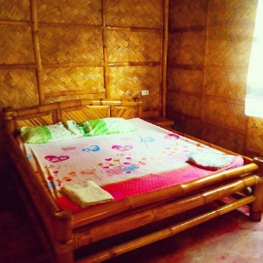

JULIA and MARK wake up. Julia is pregnant with her 2nd child.

JULIA

Good morning Love!

MARK

Good morning! Isn’t it a good day? How’s our baby?

JULIA

Very good!... Wait(looks outside), the weather’s very good too.

Background:

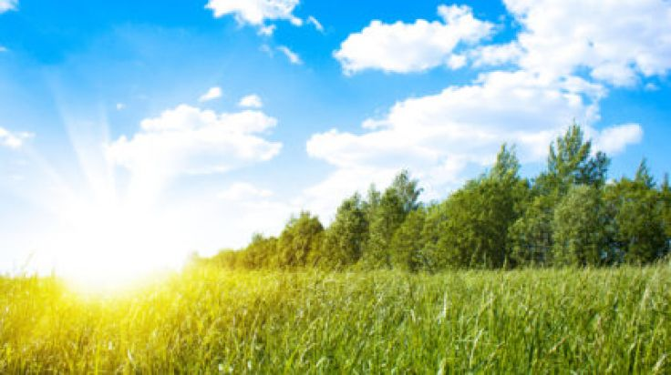

PETCHIE comes in.

PETCHIE

Mama! Papa! Good morning! Let’s eat. I’m hungry!

JULIA

Okay, okay. But we need to gather first from what we farmed.

**Scene 2**: Farming Scene

(This scene explains that the that the Land is the source of life & ‘Mother Earth’ and Indigenous law)

The family goes out the house and kisses the ground as a sign of respect to Mother Earth.

Background:

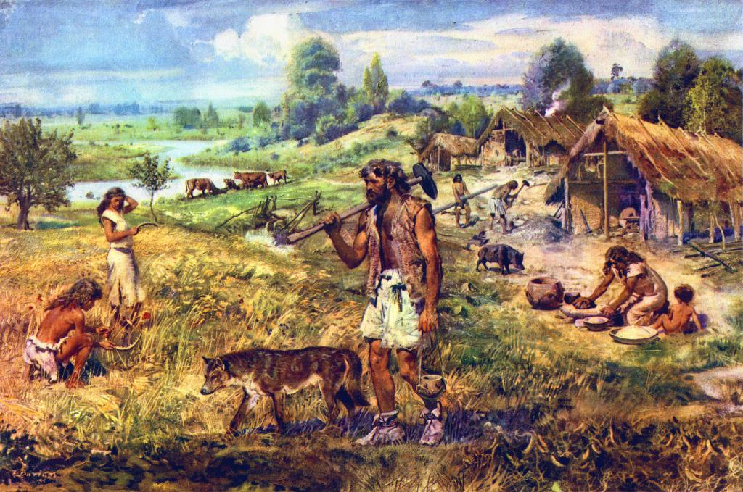

The family gathers food. While gathering…

PETCHIE

Ma? Why do we always kiss the ground every day when we go out the house?

JULIA

Child, it’s because the land is the source of wealth and life.

PETCHIE

What do you mean ma?

JULIA

Your father will explain it to you.

MARK

Petchie, Land is the source of life – a gift from the creator that nourishes, supports and teaches; material and spiritual worlds are woven together in one complex web, so each living thing has a sacred meaning. This is why we must respect and care for Mother Earth.

PETCHIE

Ohhh!

JULIA

Yes! ‘Mother Earth’ – the center of the universe, the core of their culture, the origin of their identity as a people.

PETCHIE

Okay Ma!

JULIA

And also, we do not owe anything in this world. We are only a steward, a care-taker of this land. We have the responsibility to take care of Mother Earth. This is the Indigenous Law – Lands should not be owned.

PETCHIE

Yes Ma! But… Ma? Pa? Why are you telling me this?

JULIA

Wala lang… Trip lang nak! Hahaha

Petchie gives an awkwards silence and stare.

PETCHIE

(Sarcastically) Nag joke ka Ma?

JULIA

Kidding aside, you are of the age Petchie. You should know these things already as you will share this in the next generation soon.

MARK

Let’s eat!

Background:

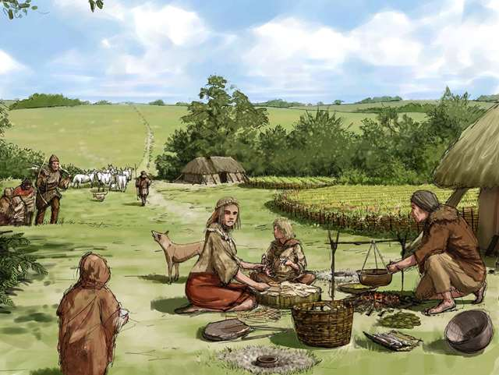

**Scene 3:** Family Walking Over the Land Scene

(This scene explains Ancestral lands)

Background:

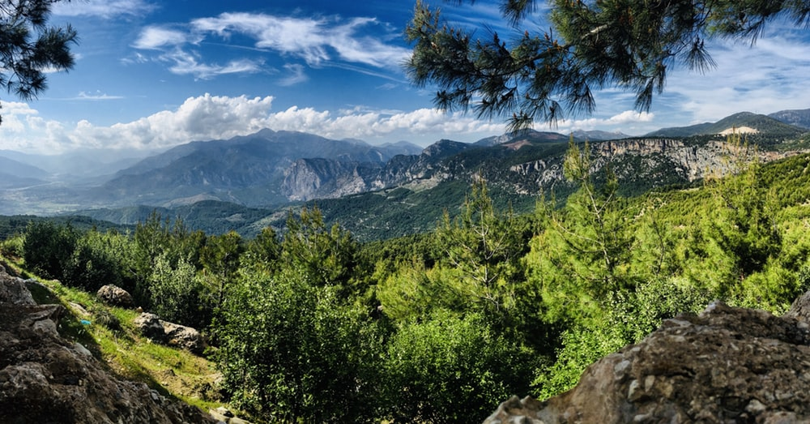

MARK

The view, isn’t it wonderful?

PETCHIE

Yes Pa! It’s very nice!

MARK

These are the Ancestral Lands. The lands of which our forefathers come from and lived.

JULIA

They settled here for there is an abundance in resources that are available.

MARK

Ancestral lands are not merely an economic resource, but are literally the source of life for the rich natural resources.

PETCHIE

Ma, Pa, thank you for bringing me here. I know understand that we must take care of the place we live in. I love you!

JULIA, MARK

We love you nak.

THE END.

**Reference:**

